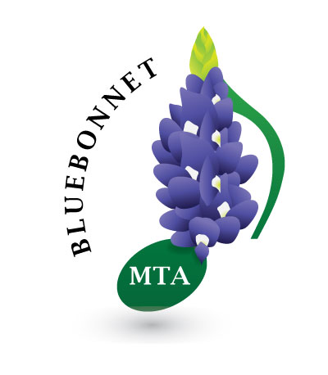
Bluebonnet Music Teachers Association
http://bluebonnetmta.org/

Trophies for Festivals, Competitions and Theory

Students participating in BMTA Festivals and Competitions will receive points for festivals and competitions.
An Excellent rating is worth 1 point,
a Superior minus is worth 2 points,
a Superior is worth 3 points,
a Superior plus is worth 4 points.

Students also get points for theory tests as follows

Students testing at their school grade level
Students who get a grade of 90-100 get 4 points
Students who get a grade of 80-89 get 3 points

Students testing below school grade level
Students who get a grade of 90-100 get 2 points
Students who get a grade of 80-89 get 1 point

Students get one point for performing in a Bluebonnet recital.

When a student has earned 12 points, he will be awarded a Trophy.
The trophies will be engraved student name, Bluebonnet MTA - year.

2020-2021 | 2021-2022 | 2022-2023 | 223-2024 | 2024-2025 | 2025-2026

