Bluebonnet MTA 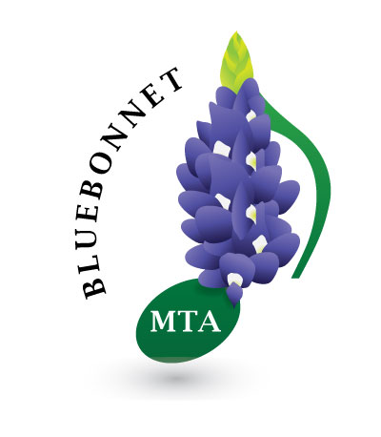

2022 – 2023
Performance Events

Festivals, Recitals, Competitions

